Iteration 4 Report

Public Health App, Team Coding Touchdown

1. **Customer Meeting Date to Demo**

Nov 17, Friday, 9:30pm, via Zoom

1. **User Story Implemented**

The following are the specific tasks we completed in this iteration:

2.1. We created 4 more surveys at the front-end.

2.2. We updated the front-end and the back-end logic of survey 1.

2.3. We modify our database to add the userId into our Survey documents for mongoDB. Now we can query the survey completed by the user in order to display the result of the survey in the front-end.

1. **Design Diagram**

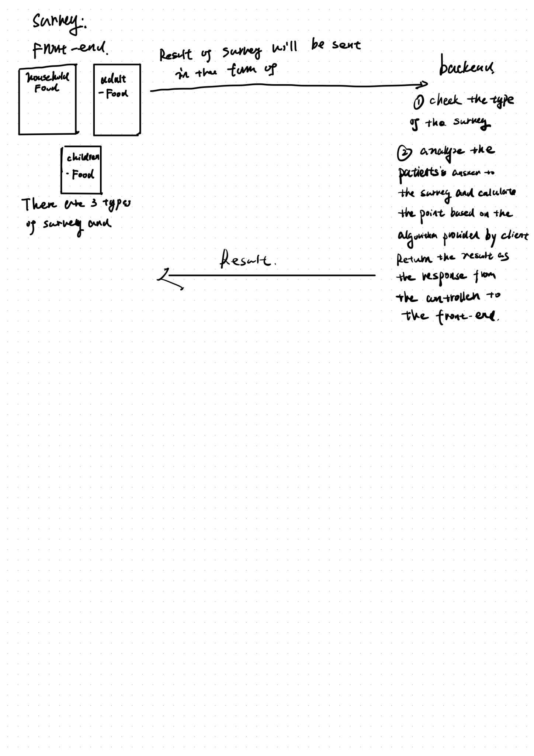

1. **Note to the User Story**

The main target of this iteration is to maintain and refactor user stories we have done in iterations before. More copies of user stories “Answer Screening Questions” and “Check Screening Results” are completed in this iteration. What’s more, we updated some user stories completed before.

1. **Evaluation of the Code and Tests**

You could run the test case by ‘npm test’ in the public-health-app folder.

The coverage of the code will also be displayed. Before running the code please run the ‘npm install -f “ and “npm install -f nodemail” to install the essential dependencies for the project in order to run the test.

1. **Links**

Pivotal Tracker: <https://www.pivotaltracker.com/n/projects/2596722>

GitHub repo: <https://github.com/Patrickyyh/public-health-app>

Heroku deployment: [https://publichealthapp.herokuapp.com/](https://publichealthapp.herokuapp.com/register)